Case Study of Shree Shyam Ji Store

A PROPOSAL REPORT FOR THE BDM CAPSTONE PROJECT

IMRAN ASHRAF 22f1001972 MAY 2023 TERM



INDIAN INSTITUTE OF TECHNOLOGY, MADRAS, CHENNAI TAMIL NADU, INDIA, 600036

(BS) DEGREE IN DATA SCIENCE AND APPLICATIONS

# Declaration Statement

I am working on a Project titled **Case Study of Shree Shyam Ji Store** I extend my appreciation to Shree Shyam Ji Store (kirana Store), for providing the necessary resources that enabled me to conduct my project.

I hereby assert that the data presented and assessed in this project report is genuine and precise to the utmost extent of my knowledge and capabilities. The data has been gathered from primary sources and carefully analyzed to assure its reliability.

Additionally, I affirm that all procedures employed for the purpose of data collection and analysis have been duly explained in this report. The outcomes and inferences derived from the data are an accurate depiction of the findings acquired through thorough analytical procedures.

I am dedicated to adhering to the principles of academic honesty and integrity, and I am receptive to any additional examination or validation of the data contained in this project report.

I understand that the execution of this project is intended for individual completion and is not to be undertaken collectively. I thus affirm that I am not engaged in any form of collaboration with other individuals, and that all the work undertaken has been solely conducted by me. In the event that plagiarism is detected in the report at any stage of the project's completion, I am fully aware and prepared to accept disciplinary measures imposed by the relevant authority.

I understand that all recommendations made in this project report are within the context of the academic project taken up towards course fulfillment in the BS Degree Program offered by IIT Madras. The institution does not endorse any of the claims or comments.

Signature of Candidate: 

Name: Imran Ashraf

Date: 1 July 2024

# Executive Summary

Store Selection and Data Collection Process

Shop Selection:

The data regarding this project has been collected from a medium-scale Kirana shop at Pratap Vihar, Ghaziabad. The reasons for the choice of that shop are as follows :-

1. **Proximity**: The shop is located in my residential vicinity, hence commuting was easy and convenient to make regular visits.
2. **Appropriate Scale:** The scale and size of the business were appropriate for the scope of this project.
3. **Owner Cooperation:** The proprietor of this shop has been very cooperative and is ever ready to release this business data.
4. **Customer Relationship:** I happen to be a daily customer, therefore developed rapport with the owner for easier collection of the data.
5. **Owner's Education:** The owner is educated to a lower level hence understood and supported my proposal easily.

Data Collection:

For gathering this data, I have personally gone to the store owner and collected it through the following:

* **Local Store Record Books:** The data is recorded by the store itself. It keeps record books on its stock and sale details.
* **All Previous Issued Bills:** Previous bills issued are kept with the owner, which include 90% of the transaction data for customer receipts.

Presently, I have collected 30 days of data and taken the initiative to collect more data until a relevant conclusion is met from the help of the business model.

Data Collected for Products:

The data collected consisted of manifold vital products that the store sold. These products have been listed below:

* Grain:
  + Rice
  + Atta(wheat flour)
  + Toor dal(pigeon peas)
  + Moong dal(green gram)
  + Urad dal(black gram)
* Sweeteners:
  + Sugar
* Dairy Products:
  + Milk
  + Curd
  + Paneer(cottage cheese)
  + Cheese
* Fats
  + Ghee(clarified butter)
* Dry Fruits:
  + Almonds
  + Cashews
  + Raisins(dried grapes)

The process of collection and analysis of this data is to be continued till appropriate actionable insights could be derived that would increase the efficiency of the operations and profitability of the store.

# Organisation Background

**Shree Shyam Ji Store**

**Name of Store:** Shree Shyam Ji Store

**Owner**: Mr. Brijesh Kumar

**Address**: L-92, Sector -12, Pratap Vihar, Ghaziabad – 201009

Overview:

Shree Shyam Ji Store is a well-established Kirana shop that sells daily consumed goods like:-

* Different types of Dal(Toor, Moong, Urad, etc.)
* Sugar
* Salt
* Edible Oils
* Ghee
* Dry Fruits (Almonds, Cashews, Raisins, etc.)

Establishment and Investments: -

* **Year of Establishment:-** Early, 2021
* **Initial Investment**: ₹4,00,000

The owner of this firm, Mr. Brijesh Kumar, has contributed ₹4,00,000 in this business. This investment is divided between:

* + Fixed Assets: Building with infrastructure.
  + variable Assets: Merchandise and inventory.

Current Scenario of the Business:

After leading an extensive discussion with Mr. Brijesh Kumar and my own independent analysis, I could make out that Shree Shyam Ji Store was doing fairly well in the beginning. However, with the arrival and surging growth of online marketing systems, it changed drastically for the store in terms of sales and profit margins. It has resulted in a drastic fall in customer footfall and overall profitability.

# Problem Statement

From the discussion with the owner of Shree Shyam Ji Store and my personal observation from time to time, I can easily reach this conclusion: though the store has built up a strong customer relationship network with good sales, it is suffering from a serious challenge in performance. The challenges are:

1. **Low Net Profit:**
   1. The shop has maintained good sales but still doesn't give the expected amount of net profit. That means the store is in dire need of analyzing and increasing their profit margins.
2. **Overstocked Inventory:**
   1. There is overstocking that prevails in the store, resulting in wastage of food, damage to products from overcrowding, extra expenses to the owner, etc. So, inventory management, for such reasons, plays a very important role.

Thus, keeping the above limitations in mind, the following problem statements can be given as:

1. **Inventory Optimization:**
   1. Determine an extent of this inventory for the store related to Sales and Intake so as to keep optimum levels of this stock. This would avoid wastage, reduce the damage to products, and lower the inventory costs.
2. **Profit Margin Analyses:**
   1. Current profit margins analysis: Make a case for an increase in net profit, either through cost reduction, pricing strategies, or identification of high margin products.
3. **Analysis of Competitive Performance:**
   1. Performance of the store in comparison with its immediate competitors; hence, areas for improvement will be noted. This will require accompanying strategies resulting in increased reach of the store and making the business more competitive. Probably, this may mean improving customer service, increasing marketing, or even finding new sales channels.

These key areas, if acted upon, will drive operational efficiency, thus reducing costs and increasing profitability for growth and the sustainable success of Shree Shyam Ji Store.

# Background of the Problems

Discussions with the owner, supplemented by personal experience as a regular customer, have thrown up many key issues that are affecting the performance and growth of this outlet. These are:

* **Effect of Online Shopping Boom:**

Business was good until the proliferation of online shopping sites, and the Corona lockdown proved to be the last nail in the coffin. Most of their loyal kirtanas shifted to online shopping from home for attractive discounts and avoiding inconvenient trips to markets.

* **Local Competition and Customer Base:**

Though located in the center of a heavily populated area with four to five apartment complexes surrounding this shop, the sales go well according to the size and spread. Still, fixed assets of such a store can't grow much. Though customer trust and customer base are pretty high for this store, scaling is the challenge.

* **Influencing Factors:**
  + Inadequate Sales Forecasting: The correct sales forecasting is missing in this store due to which overstocking or stockouts occur. It reduces the overall profitability.
  + Mismanagement Practice of Inventory: Due to improper management practices of the inventory, pilling up of same resulted in overfilled inventory. It menaces many problems like food wastage and damage to the product, etc.
  + Pricing Issues: Prices of dry fruits and oil are higher compared to other local shops and probably make the customers go elsewhere for the same.

# Problem-Solving Approach

**NATURE OF DATA AND METHODS USED WITH JUSTIFICATION**

The primary data to be used in this study is time series in nature and offers ample scope for a host of analytical techniques. The tools that will mostly come in handy in the analysis of the collected data and provide meaningful insights will comprise:

1. **Trend Analysis and Visualization**
   1. Trend Lines and Scatter Plots: Mode charts trend over time, mapping sales performance, inventory, and other key metrics.
   2. Pivot Tables: Active summaries of data are created with effective filtering facilities for extracting meaningful information.
   3. Pie Diagrams and Stacked Histograms: This gives the distribution and proportions of varied variables to be shown visually given in order to make a complex data set easy to understand.
2. **Financial Analysis :**
   1. I am going to compute major financial variables from ratios and financial metrics taken from the course. This would include ratios like Gross Profit Margin, Net Profit Margin, and ROCE—those very important ratios defining the financial health of a shop.

**Proposed Data to be Collected with Reasons**

Although this shop sells most varieties, ensuring manageability and conclusiveness of the data collection and analysis process, I have focused on collecting the data for 10 key products. The variables collected for the products are:

* Cost Price
* Selling Price
* Quantity Sold
* Quantity Bought

From these variables, I would compute some essential financial metrics like:

* Revenue
* Expenditure
* Gross Profit
* Net Profit
* Average Inventory
* Wastage Due to Damage

Also, I will get capital invested, liabilities, fixed assets, variable assets, labour and transportation costs data for the calculation of all the comprehensive financial ratios and metrics.

**Tools to Be Used for Analysis with Justification**

Since the data to be obtained is going to be mostly time-series data, Microsoft Excel will be used for processing and analyzing data. The following Excel tools and functions will be utilized where necessary:

1. Pivot Tables:
   1. Dynamic filtering of data, summarizing and calculating data on rows and columns.
2. Excel Functions:
   1. VLOOKUP: For finding discrete data points in huge data structures.
   2. COUNTIF and COUNTIFS: Count occurrences that meet certain criteria.
   3. Arithmetic Operators: To do the needed calculations with the data.
3. Data Visualization
   1. Pie Charts: Graphically showing the proportion of various categories.
   2. Stacked Histograms: Showing dispersion of more than one variable and relation among them.
   3. Scatter Diagrams: Graphical representation of a relationship, trends, etc., in data.
   4. Heat Maps: A graphical representation indicating density, which is used for highlighting areas of prime interest.

It is expected that upon applying these tools and methodologies, actionable insights and Strategies pertaining to how Shyam Ji store can attain improved operational efficiencies, profitability, and overall Business Performance would be elicited.

# Expected Timeline

I have successfully collected 30 days worth of data which will be first cleaned, analyzed according to which more data will be collected if needed

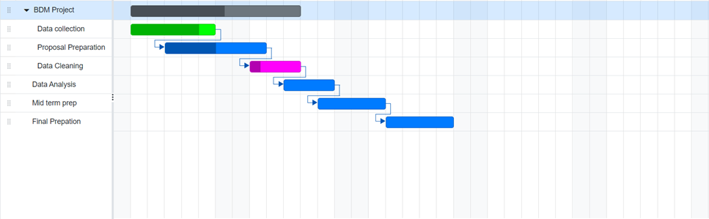

# Expected Outcomes

1. **Better Organization**
   1. Data Analysis Tools: This will have pivot tables and graphs, that will let the owner see clearly the trends of data with regards to sales, inventory etc. Thus the owner will have an idea of better organization at the business front.
   2. Visualization: Representing the data in graphs and charts of the trends freeing a person from its analysis to be used in spotting patterns, highlight areas for improvement that give insights to the owner for better decision making.
2. **Inventory management**
   1. Optimized Inventory: Suggest best practices of inventory management for avoiding overstocking and stockouts.
   2. Computerized Tracking: Develop inventory management software/ systems to computerize this tracking and hence re-supply automatically to maintain the optimum levels.
3. **Business Planning:**
   1. Higher Profit Margin: Design an all-dimension incorporating business plan focusing on enhancing customer profit margins through price mechanisms, cost saving techniques and incorporating high profitable products.
   2. Competition Plans from Online Business: Strategy how you can make your business more competitive versus online business, such as giving better service, unique products, or attractive loyalty programs.
   3. Marketing Efforts: Suggest some effective marketing techniques that can attract more customers through local advertising, ads on social media, community outreach, and so on.
   4. Digital Integrate: Plan for the integration on the tiers of digital platforms. This could mean just being online or, in a better case, offering home delivery services so that it may get to large numbers of people.

Because of that, Shree Shyam Ji Store will meet operational efficiency, inventory control, along with rising profitability; hence, the chance of flourishing store amidst online competitors gets enhanced

Images:

# Appendix A

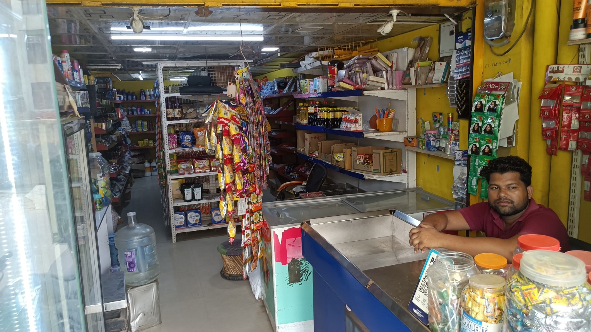

**Picture of shop**

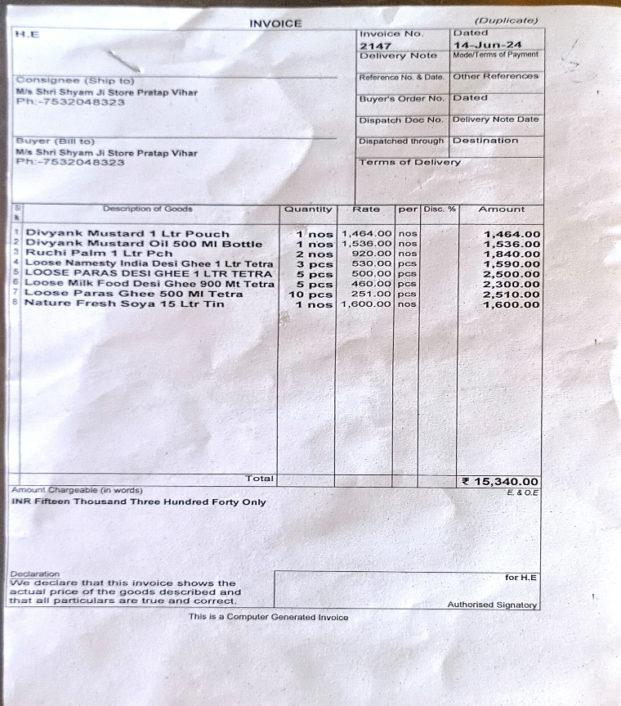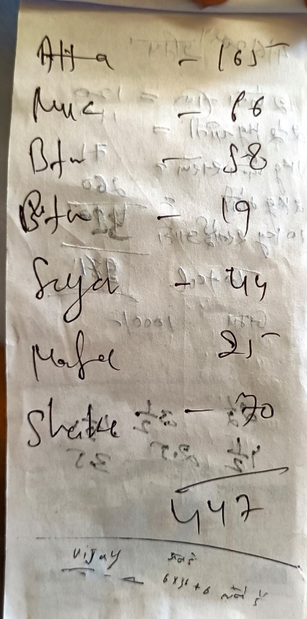

**Picture of sales record (informal)**